Lab 6-1 Creating Calculation Measures Using Logical Columns
Goals | To derive a new calculation based on existing business measures.
Scenario | You want users to be able to track the difference between the units ordered and units shipped by selecting a single fact column called Cuts. This important business measure can potentially help track lost revenue. You will configure a formula for Cuts using existing logical columns as objects in the formula. You are using existing logical columns because the physical data column names may change. The Expression Builder utility will help you configure the formula.
Outcome | In the Business Model and Mapping layer, Cuts is added to the SalesFacts logical table.  In the Presentation layer, Cuts is added to the SalesFacts presentation table.
Time | 10 – 15 minutes
Environment | 
Instructions:
- Stop the Siebel Analytics Server service.
  - Select Start > Programs > Administrative Tools > Services.
  - Right-click Siebel Analytics Server and select Stop.
  - Leave Services open.
- Start the Siebel Analytics Administration Tool and open the ABC repository offline.
  - Select Start > Programs > Siebel Analytics > Siebel Analytics Administration.
  - Select File > Open > Offline.
  - Double-click ABC.rpd to open it.
  - Verify that the login parameters are the following:
User ID | Administrator
Password | <blank>
  - Click OK.
- Define a new logical measure called Cuts (the difference between what was ordered and what was shipped) in the SalesFacts logical table that uses existing logical columns as its source.
  - In the Business Model and Mapping layer, right-click the SalesFacts logical table and select New Object > Logical Column.
  - Verify that the General tab is selected.
  - Enter Cuts in the Name field to name the column.
  - Select the Use existing logical columns as the source check box.
  - To open the Expression Builder, click the Ellipsis 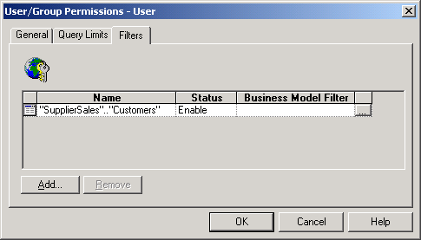 button (to the right of the text edit box).
  - In the left pane of the Expression Builder, select the Logical Tables folder.
  - In the middle pane, select the SalesFacts logical column.
  - In the right pane, select the Units Ordered logical column.
  - Click Insert.
  - Click the - minus sign on the toolbar.
  - In the right pane, select the Units Shipped logical column.
  - Click Insert. Check your results:
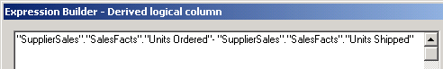
  - Click OK to close the Expression Builder.
  - Examine the data type of the new Cuts column.
    - Select the Data Type tab. Note that the formula is expressed in terms of the physical column data types even though the formula is based on logical columns.
    - What is the Data Type of the Cuts column?
  - Click OK.
- Add the new Cuts column to the SupplierSales presentation catalog.
  - In the Presentation layer, verify that the SupplierSales presentation catalog is expanded.
  - Select Cuts from the SalesFacts logical table and drag it onto the SalesFacts presentation table.
- Select File > Check Global Consistency to validate your work.
- Select File > Save to save your work.
- Select File > Exit to close the Administration Tool.
- Start the Siebel Analytics Server service and restart the Siebel Analytics Web service.
- Start Siebel Answers.
  - Select Start > Programs > Siebel Analytics > Siebel Analytics Web.
  - Enter the following parameters:
User | Administrator
Password | <blank>
  - Click Log In.
  - Click the Answers link.
- Click the SupplierSales subject area.
- Create the following request:
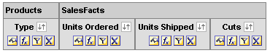
  - Click the Results tab to view the results.
    - Verify that the Cuts calculation is accurate for the Frozen food type by manually subtracting Units Shipped from Units Ordered.
    - Is the value in the Cuts column for the Frozen food type accurate?
    - Verify that the Cuts calculation is accurate for the Lamb food type by manually subtracting Units Shipped from Units Ordered.
    - Is the value in the Cuts column for the Lamb food type accurate?
- Leave Siebel Answers open.
- Examine the query log to see what query was sent to the database.
  - Double-click C:\SiebelAnalytics\Log\NQQuery.log.
  - Note that cuts is a column listed in the query and the two columns summed in the list of columns appear as sum(T56.UnitShpd) and sum(T56.UnitOrdd). Also note that there is a subquery.
  - Select File > Exit to close the query log.
Solutions 6-1 Creating Calculation Measures Using Logical Columns
Answers
3.n.ii. What is the Data Type of the Cuts column?
INT
11.a.i. Click the Results tab to view the results.
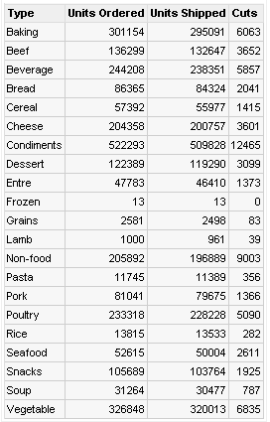
11.a.ii. Is the value in the Cuts column for the Frozen food type accurate?
Yes, 0 is the correct value.
11.a.iv. Is the value in the Cuts column for the Lamb food type accurate?
Yes, 39 is the correct value.
Lab 6-2 Creating Calculation Measures Using Physical Columns
Goals | To modify a repository in Online mode and create a calculation measure using physical columns.
Scenario | You want users to be able to track the difference between the units ordered and units shipped by selecting a single fact column called CutsP. You will configure a formula for CutsP using physical columns as objects in the formula. The Expression Builder utility will help you configure the formula.
Outcome | In the Business Model and Mapping layer, CutsP is added to the SalesFacts logical table.  In the Presentation layer, CutsP is added to the SalesFacts presentation table.
Time | 10 – 15 minutes
Instructions:
- Since you will be opening the ABC repository in Online mode, verify that the Siebel Analytics Server service is started.
  - Return to Services and verify that the Siebel Analytics Server status is Started.
  - Leave Services open.
- Start the Siebel Analytics Administration Tool and open the ABC repository in Online mode.
  - Select Start > Programs > Siebel Analytics > Siebel Analytics Administration.
  - Select File > Open > Online.
  - In the Open Online Analytics Web dialog box, verify the following parameters:
User ID | Administrator
Password | <blank>
  - Click Open.
- Verify that a user preference is set to check out objects automatically.
  - On the menu bar, select Tools > Options.
  - Select the General tab.
  - Make sure that the Check out objects automatically check box is selected.
  - Click OK.
- Configure a new column in the SalesFacts table that will use physical columns as its source.
  - In the Business Model layer, right-click the SalesFacts table and select New Object > Logical Column.
  - Type CutsP in the Name field to name the column.
  - Set the aggregation rule to Sum.
    - Select the Aggregation tab.
    - In the Default aggregation rule field, click the drop-down arrow and select Sum.
    - Click OK. Notice that the icon for CutsP is blue. This indicates that the logical column has not yet been checked in to the server.
- Map the new CutsP column to a physical source.
  - In the Business Model and Mapping layer, expand the Sources folder for the SalesFacts table and double-click D1_Orders2.
  - Select the Column Mapping tab.
  - Select the Show unmapped columns check box.
  - To open the Expression Builder, click the CutsP ellipsis (…) button.
  - Display the physical table and column names.
    - In the left pane of the Expression Builder, select the Physical Tables folder.
    - In the middle pane, select the table, D1_Orders2.
  - Following the process used in the previous exercise, create a formula that subtracts units shipped from units ordered using physical columns. Check your results:
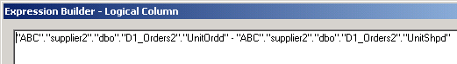
  - Click OK to close the Expression Builder.
  - Click OK to close the properties window.
- Add the new column to the SupplierSales presentation catalog.
  - Select CutsP from the SalesFacts logical table and drag it onto the SalesFacts presentation table in the Presentation layer.
- Check in the changes made to the repository:
  - Select File > Check In Changes.
  - Reply Yes to the Check consistency? message.
  - Click OK.
- Select File > Save to save the repository changes.
- Select File > Exit to close the Administration Tool.
- Reload the server metadata in Siebel Answers.
  - Return to Siebel Answers.
  - Click the Reload Server Metadata link to update the repository.
- Create the following request:
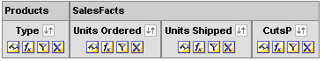
  - Click the Results tab to view the results.
  - Verify that the CutsP calculation is accurate for the Frozen food type by manually subtracting Units Shipped from Units Ordered. Is the value in the CutsP column accurate?
  - Verify that the CutsP calculation is accurate for the Lamb food type by manually subtracting Units Shipped from Units Ordered. Is the value in the CutsP column accurate?
- Select File > Close to close Siebel Answers.
- Examine the query log to see what query was sent to the database:
  - Double-click C:\SiebelAnalytics\Log\NQQuery.log.
    - Note that CutsP is a column listed in the query, and that the two columns summed in the list of columns appear as sum(T56.UnitOrdd - T56UnitShpd). Also note that there is no subquery.
  - Select File > Exit to close the query log.
Solutions 6-2 Creating Calculation Measures Using Physical Columns
Answers
11.a. Click the Results tab to view the results.
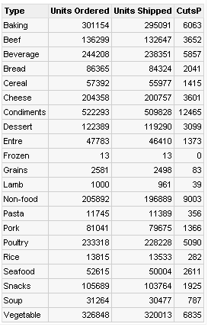
11.b. Verify that the CutsP calculation is accurate for the Frozen food type by manually subtracting Units Shipped from Units Ordered. Is the value in the CutsP column accurate? Yes, 0 is the correct value.
11.c. Verify that the CutsP calculation is accurate for the Lamb food type by manually subtracting Units Shipped from Units Ordered. Is the value in the CutsP column accurate? Yes, 39 is the correct value.
Lab 6-3 Creating Calculation Measures Using the Calculation Wizard
Goals | To modify a repository in Offline mode and create calculation measures using the Calculation Wizard.
Scenario | You want to model two calculation measures using the Calculation Wizard, called Chg Units Shipped and % Chg Units Shipped. The Chg Units Shipped measure calculates the difference between the units ordered and units shipped. The % Chg Units Shipped measure calculates what percentage of the units ordered has not shipped. The calculation measures that are created by the wizard are based on existing logical columns. You will rename these columns to CutsW and Percent Not Shipped in the Presentation layer.
Outcome | In the Business Model and Mapping layer, Chg Units Shipped and % Chg Units Shipped are added to the SalesFacts logical table.  In the Presentation layer, CutsW and Percent Not Shipped are added to the SalesFacts presentation table.
Time | 10 – 15 minutes
Instructions:
- Stop the Siebel Analytics Server.
  - Return to Services.
  - Right-click Siebel Analytics Server and select Stop.
  - Leave Services open.
- Start the Siebel Analytics Administration Tool and open the ABC repository offline.
  - Select Start > Programs > Siebel Analytics > Siebel Analytics Administration.
  - Select File > Open > Offline.
  - Double-click ABC.rpd to open it.
  - Verify that the login parameters are the following:
User ID | Administrator
Password | <blank>
  - Click OK.
- To model two calculation measures using the Calculation Wizard, start the Calculation Wizard from the Analytics Administration Tool.
  - In the Business Model and Mapping layer, expand the SalesFacts table and right-click the Units Ordered column and select Calculation Wizard.
  - In the Calculation Wizard – Introduction dialog box, click Next.
  - In the Compare “Units Ordered” with section, select the Units Shipped check box.
  - In the Generate Calculations section, verify that the Change and Percent Change check boxes are both checked.
  - In the Generate Calculations section, verify that Change is highlighted.
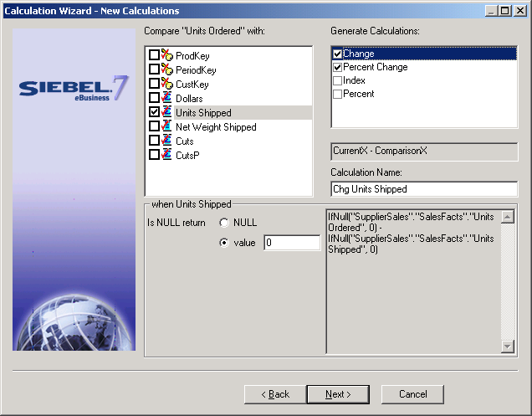
  - Specify what result you want if the Change value is not available or zero using the following parameters:
  - In the Generate Calculations section, select Percent Change so that is highlighted.
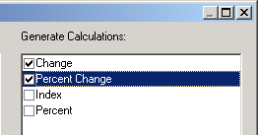

  - Specify what result you want if a value is not available or is zero using the following parameters:
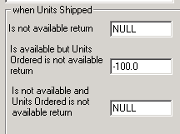
  - Click Next.
- Review the two calculations measures that are modeled by the Wizard and click Finish.
  - In the Business Model and Mapping layer, locate the two columns created by the Calculation Wizard in the SalesFacts table. What are the new column names?
- Add the new columns to the SupplierSales presentation catalog.
  - Drag the new Chg Units Shipped and % Chg Units Shipped columns from the SalesFacts logical table onto the SalesFacts presentation table in the Presentation layer.
  - Rename the columns to the following:
(Hint: You will have to deselect the Use Logical Column Name check box in the properties window to rename the presentation columns.)
From… | To…
Chg Units Shipped | CutsW
% Chg Units Shipped | Percent Not Shipped
- Select File > Check Global Consistency to validate your work.
- Select File > Save to save your work.
- Select File > Exit to close the Administration Tool.
- Start the Siebel Analytics Server service and restart the Siebel Analytics Web service.
- Start Siebel Answers.
  - Select Start > Programs > Siebel Analytics > Siebel Analytics Web.
  - Enter the following parameters:
User | Administrator
Password | <blank>
  - Click Log In.
  - Click the Answers link.
- Click the SupplierSales subject area.
- Create the following request:
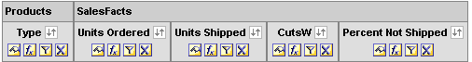
  - Click the Results tab to view the results. Note that Percent Not Shipped is displayed in dollars. You will change this to percentage in a later step in this lab.
    - Verify that the CutsW calculation is accurate for the Frozen food type by manually subtracting Units Shipped from Units Ordered. Is the value in the CutsW column accurate?
    - Verify that the CutsW calculation is accurate for the Lamb food type by manually subtracting Units Shipped from Units Ordered. Is the value in the CutsW column accurate?
    - To verify that the Percent Not Shipped value is accurate, you would divide CutsW by Units Shipped. For example, for the Lamb food type, you would divide 39 by 961 to get 4.06. This tells you that 4.06% of the units ordered have not shipped.
- Format the Percent Not Shipped column to display percentages instead of dollars.
  - Click the Edit View icon for the table.
  - In the Percent Not Shipped column, click the Format Column icon.
  - Select the Value Format tab.
  - Select the Override Default Data Format check box.
  - In the Treat Numbers As drop-down list, select Percentage.
  - In the Digits drop-down list, select 2.
  - Verify your changes:
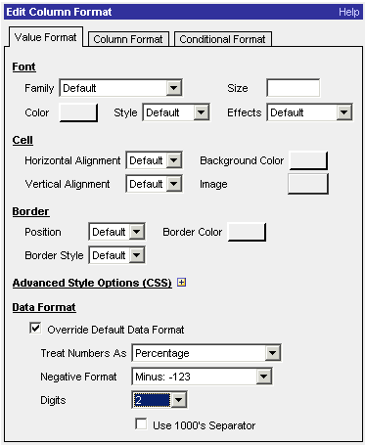
  - Click OK.
  - Notice that the format of the Percent Not Shipped column is now changed from dollars to percentages.
- Select File > Close to close Siebel Answers.
- Examine the query log to see what query was sent to the database.
  - Double-click C:\SiebelAnalytics\Log\NQQuery.log.
  - Note that CutsW is a column listed in the query. Also note the percentage calculation.
  - Select File > Exit to close the log file.
Solutions 6-3 Creating Calculation Measures Using the Calculation Wizard
Answers
4.a. In the Business Model and Mapping layer, locate the two columns created by the Calculation Wizard in the SalesFacts table. What are the new column names?
Chg Units Shipped and % Chg Units Shipped
12.a. Click the Results tab to view the results.
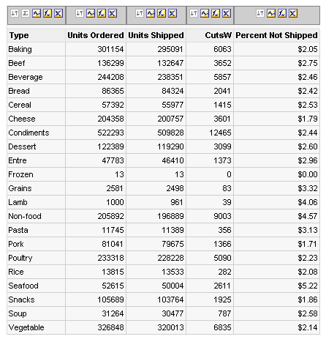
12.a.i. Verify that the CutsW calculation is accurate for the Frozen food type by manually subtracting Units Shipped from Units Ordered. Is the value in the CutsW column accurate? Yes, 0 is the correct value.
12.a.ii. Verify that the CutsW calculation is accurate for the Lamb food type by manually subtracting Units Shipped from Units Ordered. Is the value in the CutsW column accurate? Yes, 39 is the correct value.
13.i. Notice that the format of the Percent Not Shipped column is now changed from dollars to percentages.
